12 March 2024

Physics in the Pub NOMINATIONS are OPEN with a NEW Venue and Sponsors - Tuesday 27 August 2024

Nominations are NOW open for physics enthusiasts to express interest in presenting an EIGHT-minute entertaining presentation of various forms, (e.g. comedy, music, quiz, demonstrations) on some aspect of physics at the 2024 NSW Australian Institute of Physics in the Pub.

The 2024 event will be held on Tuesday 27th August from 6:00pm at our new exciting venue:
100 Broadway, Chippendale https://www.abercrombie.sydney/

The 2024 event is proudly supported by both FLEET (ARC Centre of Excellence in Future Low-Energy Electronics Technologies) and EQUS Australian Research Council Centre of Excellence for Engineered Quantum Systems

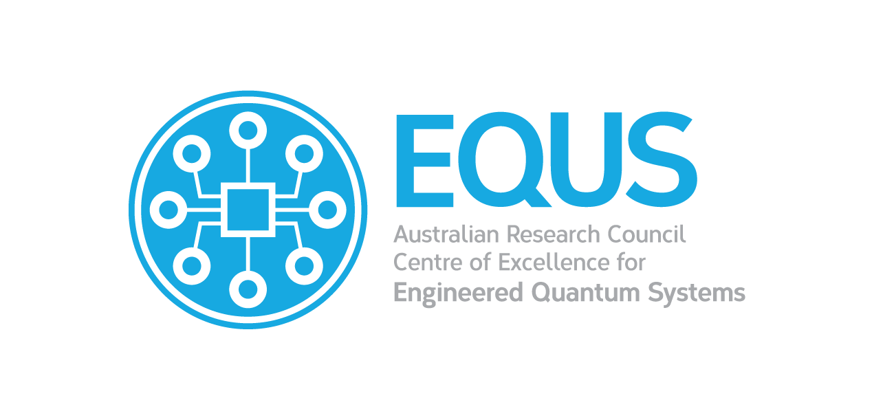

Event details
- Acts are limited to strictly eight minutes.
- Available resources at the venue: powerpoint, screen, mac, microphone, PA sound system, dimmable lights.
- Participants need to inform us of their requirements for AV, sound, tables, power, etc before the night.
- Presentations are displayed from laptop provided only, to prevent AV hiccups. We’ll assist with downloading material and testing in advance
- There are limited slots available on the night: we will do our best to include as many participants as possible, selection will be based on showcasing a range of performances and experience.
- There will be limited help available for setup and packup, for heavy or complicated equipment so please BYO roadies.
- There will be photos, videos and livestream taken on the night – let me know if you do not want these shared on social media or used for future promotional purposes.
- Participants must ensure that the stage is clean and tidy for the next participant.

To nominate as a presenter in this event, a statement of up to 200 words outlining the description will be required below for submission on this form by the due date to fit the following criteria:

- Title: Is the title adequate and interesting for a Physics Variety presentation?
- Structure: Is the structure of the description well organized and good enough to fit the EIGHT-minute Physics Variety Night presentation format?
- Relevance: Is the presentation relevant and interesting to a field of physics?
- The AIPNSW events committee will agree on the final list of approved nominee acts for 2024. All nominees will be informed by email after the closing date.

Insert up to 200 words description of subject here:
Insert up to 100 words description of presentation format here:

Complete nominee details here:
Nominee
Affiliation
Presentation title (draft)
Phone number
Email
Twitter

Nominations to present at the Physics in the Pub event will strictly close on Friday 28th June 2024. Everyone is welcome to express interest in presenting the details in this attached nomination form to:

Dr Frederick Osman FAIP
Secretary
The Australian Institute of Physics of New South Wales
Email: aip_branchsecretary_nsw@aip.org.au

